Lab 09 - Recognizing intents with Conversational Language Understanding (CLU)
Introduction:
Using intent recognition, your applications, tools, and devices can determine what the user wants to initiate or do based on options you define in Conversational Language Understanding (CLU) model.
Lab Type : Instructor Led
Estimated Duration :15 min
Objective: In this Lab, you'll use Speech and Language services to recognize intents from audio data captured from a microphone. Specifically, you'll use the Speech service to recognize speech, and a Conversational Language Understanding (CLU) model to identify intents.
Prerequisites
- Create a Speech resource and Key which you have performed in Lab 08.
Set up the environment
The Speech SDK is available as a NuGet package and implements .NET Standard 2.0. You install the Speech SDK later in this guide, but first check the SDK installation guide for any more requirements.

Task 1: Set environment variables
This task requires environment variables named LANGUAGE_KEY, LANGUAGE_ENDPOINT, SPEECH_KEY, and SPEECH_REGION.
Your application must be authenticated to access Cognitive Services resources. For production, use a secure way of storing and accessing your credentials. For example, after you get a key for your [Speech resource .CognitiveServicesSpeechServices "Create a Speech resource", write it to a new environment variable on the local machine running the application.
To set the environment variables, open a console window, and follow the instructions for your operating system and development environment.
- To set the LANGUAGE_KEY environment variable, replace your-language-key with one of the keys for your resource.
- To set the LANGUAGE_ENDPOINT environment variable, replace your-language-endpoint with one of the regions for your resource.
- To set the SPEECH_KEY environment variable, replace your-speech-key with one of the keys for your resource.
- To set the SPEECH_REGION environment variable, replace your-speech-region with one of the regions for your resource.
- Open command prompt and create Recognize-intents directory with mkdir Recognize-intents and then run cd Recognize-intents to get into the directory.
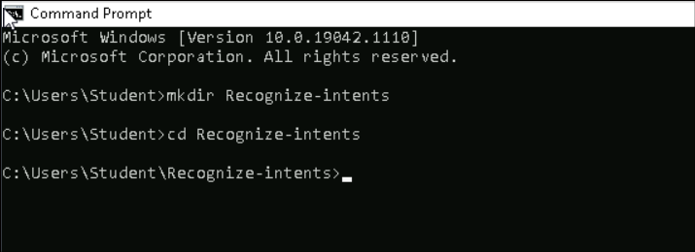
- Update below commands with your Speech , Language keys and language end keys which were copied in Lab 08 and then run them
setx LANGUAGE_KEY your-language-key
setx LANGUAGE_ENDPOINT your-language-endpoint
setx SPEECH_KEY your-speech-key
setx SPEECH_REGION eastus
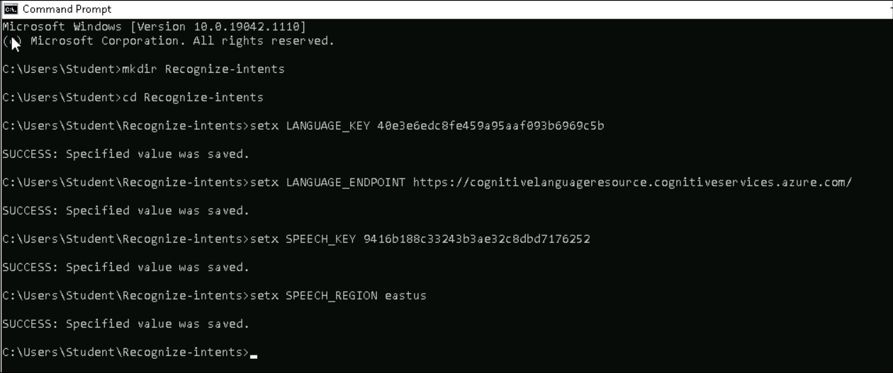
Note: If you only need to access the environment variable in the current running console, you can set the environment variable with set instead of setx.
- After you add the environment variables, you need to restart console window to read the environment variable,
Create a Conversational Language Understanding project
Once you have a Language resource created, you now must create a conversational language understanding project in Language Studio. A project is a work area for building your custom ML models based on your data. Your project can only be accessed by you and others who have access to the Language resource being used.

Task 2: Create a conversational language understanding project
For this guide, you can use C:\Labfiles\HomeAutomationDemo.json and import it. This project can predict the intended commands from user input, such as turning lights on and off.
- Open a new tab and Go to the Language Studio (https://aka.ms/languageStudio) and sign in with your Azure account.
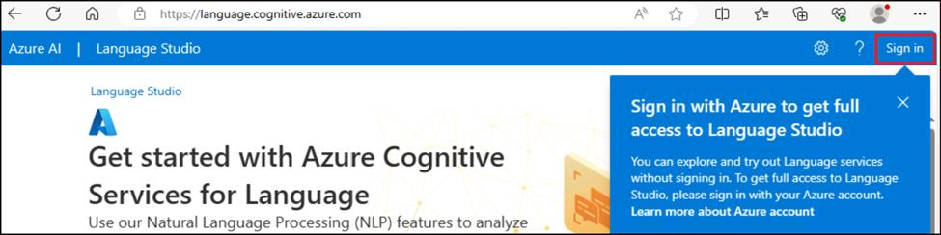
- Close the Welcome winodw.
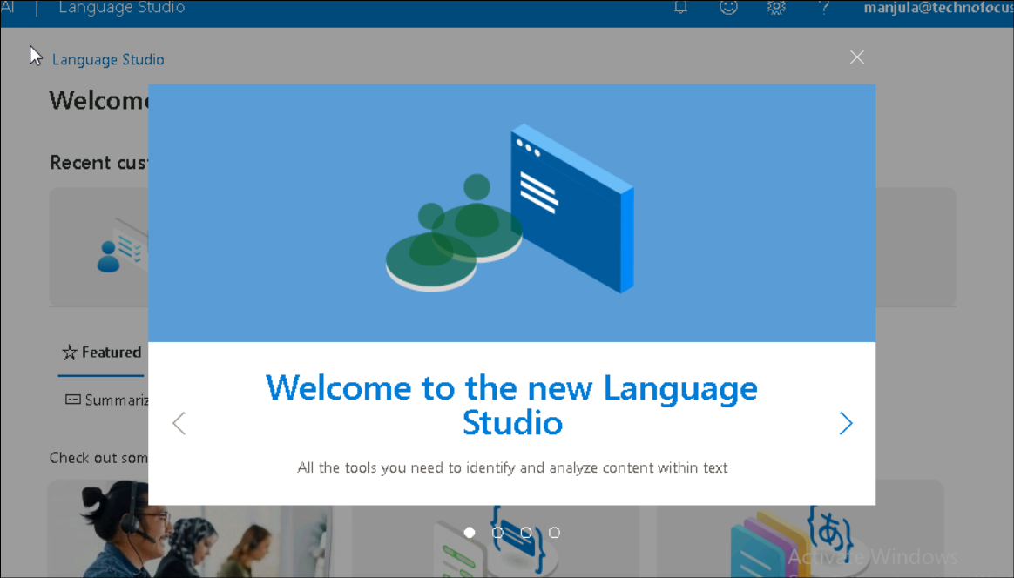
- In Select an Azure resource window, select below details and then click on Done.
  - Azure Directory: Contoso
  - Subscription: Your Azure subscription
  - Resource Type: Language
  - Resource name: CongnitivelanguageResource ( which was created in Lab 08)
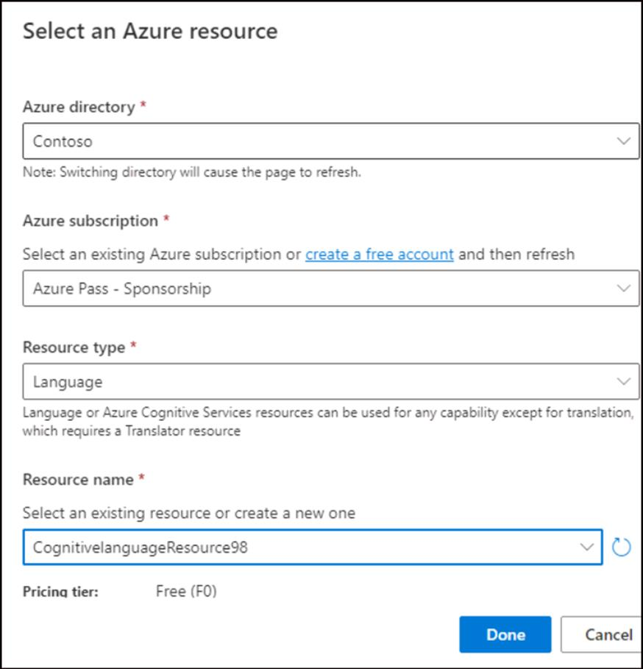
- Click on Understand questions and conversational language tab in Language Studio home page, select Conversational language understanding.
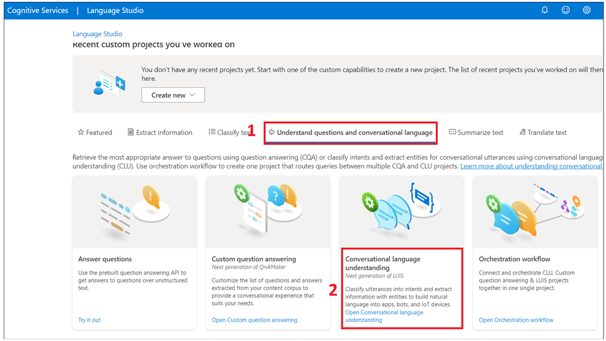
- This will bring you to the Conversational language understanding projects page. Next to the Create new project button select Import.
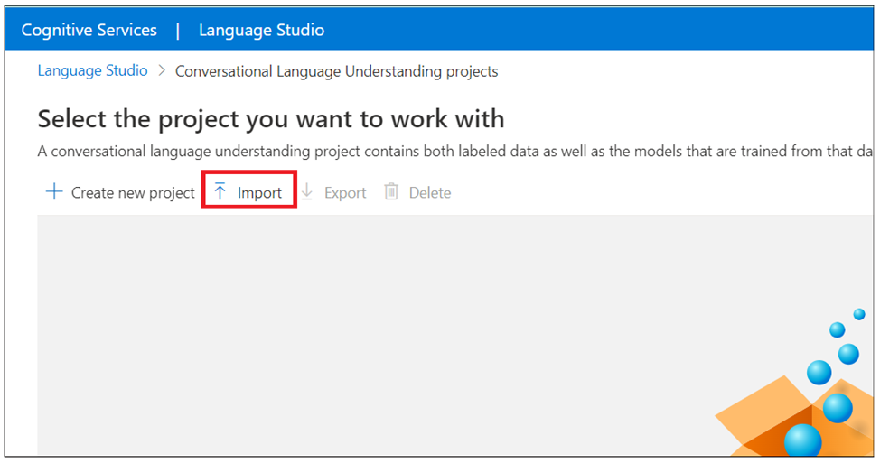
- Click on Choose file and then browse to C:\Labfiles and select HomeAutomationDemo.json click on Open
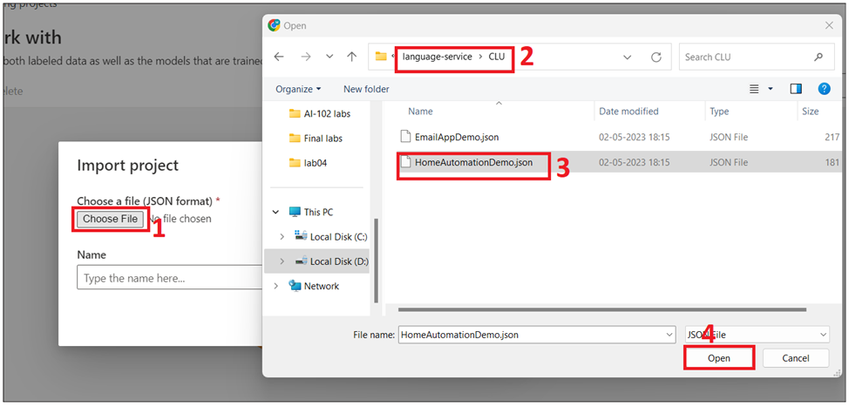
- Enter Project name: RI-HomeAutomationDemo and then click on Done.
- Once the upload is complete, you will land on Schema definition page. For this lab, the schema is already built, and utterances are already labeled with intents and entities.
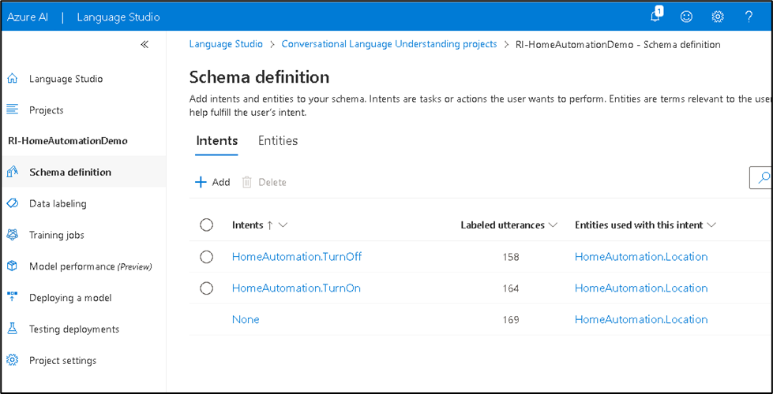

Task 3: Train your model
Typically, after you create a project, you should build a schema and label utterances.You already imported a ready project with built schema and labeled utterances.
To train a model, you need to start a training job. The output of a successful training job is your trained model.
To start training your model from within the Language Studio - https://aka.ms/languageStudio
- While you are in the Language Studio portal, Click on the right arrow on the Language studio page to view the options

- Select Training Jobs from the left side menu. Select Start a training job from the top menu.
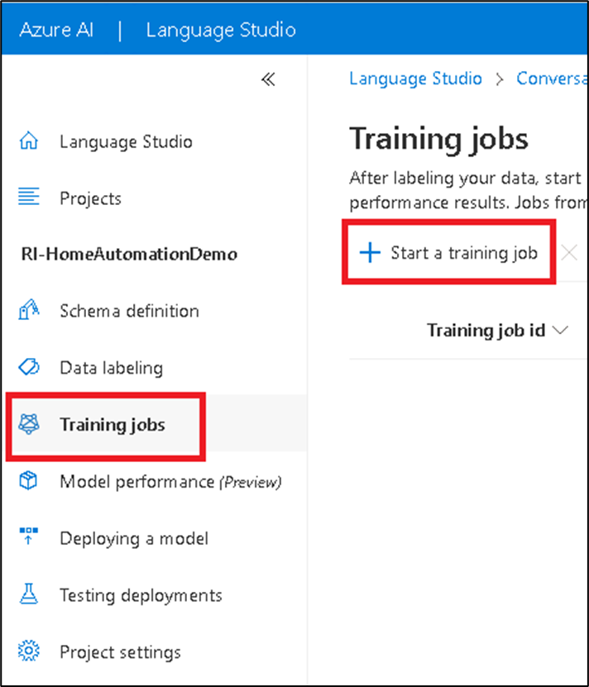
- Select below details and then click on Train.
  - Select Train a new model and enter a new model name in the text box:HomeAutomationTraining
Note: You can replace an existing model with a model trained on the new data, select Overwrite an existing model and then select an existing model. Overwriting a trained model is irreversible, but it won't affect your deployed models until you deploy the new model.
  - Training mode: Select Standard training for faster training, but it is only available for English.
Note: You can choose Advanced training which is supported for other languages and multilingual projects, but it involves longer training times.
  - Data splitting : Select Automatically splitting the testing set from training data where the system will split your utterances between the training and testing sets, according to the specified percentages. Or you can Use a manual split of training and testing data, this option is only enabled if you have added utterances to your testing set when you labeled your utterances.
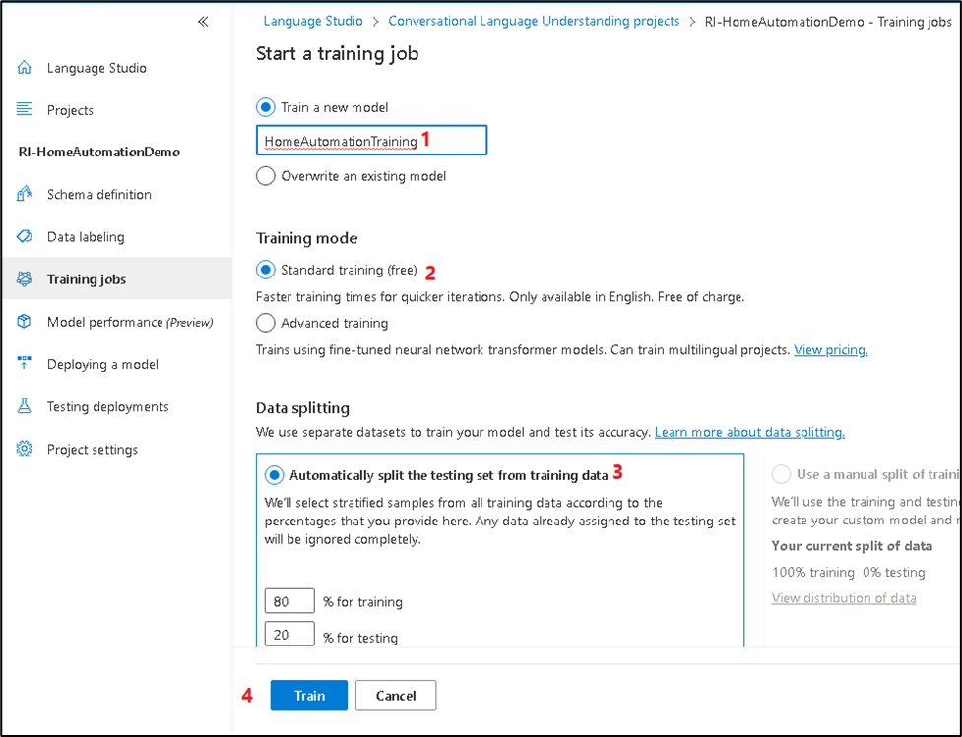
- Click on the training job ID from the list. A panel will appear where you can check the training progress, job status, and other details for this job. Wait until the Training to be successful.
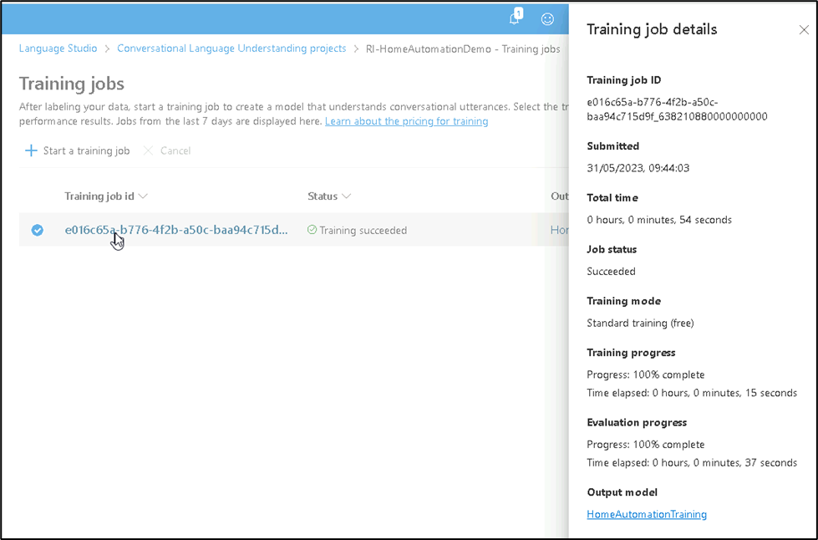
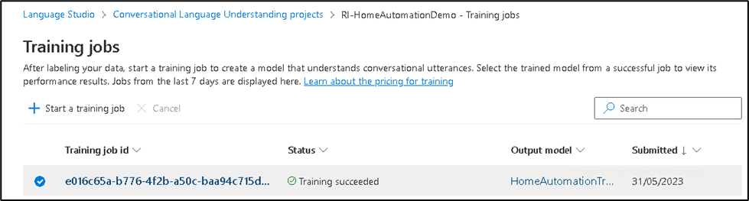

Task 4: Deploy your model
Generally after training a model you would review its evaluation details. In this lab, you will just deploy your model, and make it available for you to try in Language studio, or you can call the prediction API.
To deploy your model from within the Language Studio https://aka.ms/LanguageStudio
- While you are in the Language studio, Select Deploying a model from the left side menu. Select Add deployment to start the Add deployment wizard.
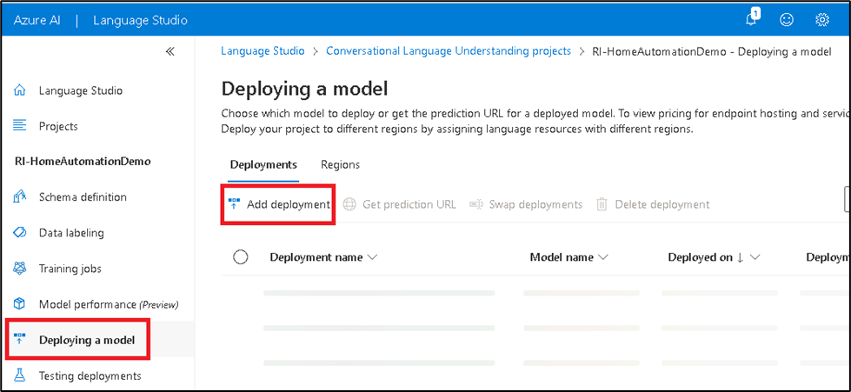
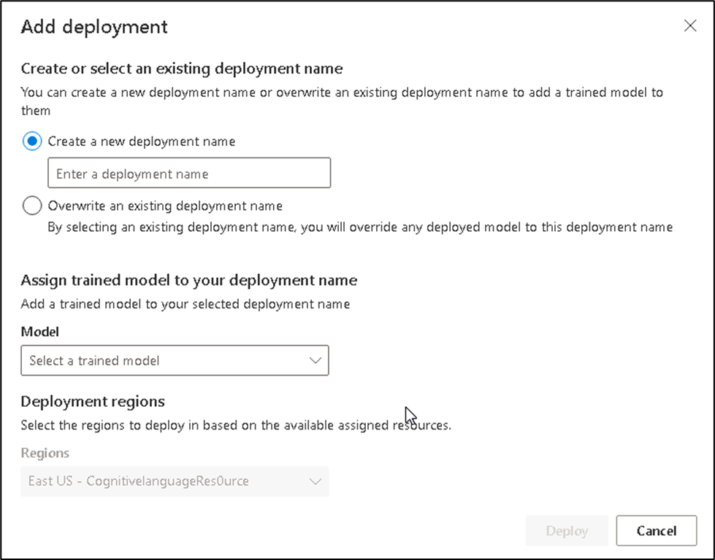
- Select Create a new deployment name to create a new deployment and enter below details andthen click on Deploy.
  - Name: HomeAutomationdeployment
  - Select a your trained model (HomeAutomationTraining) from the Model dropdown.
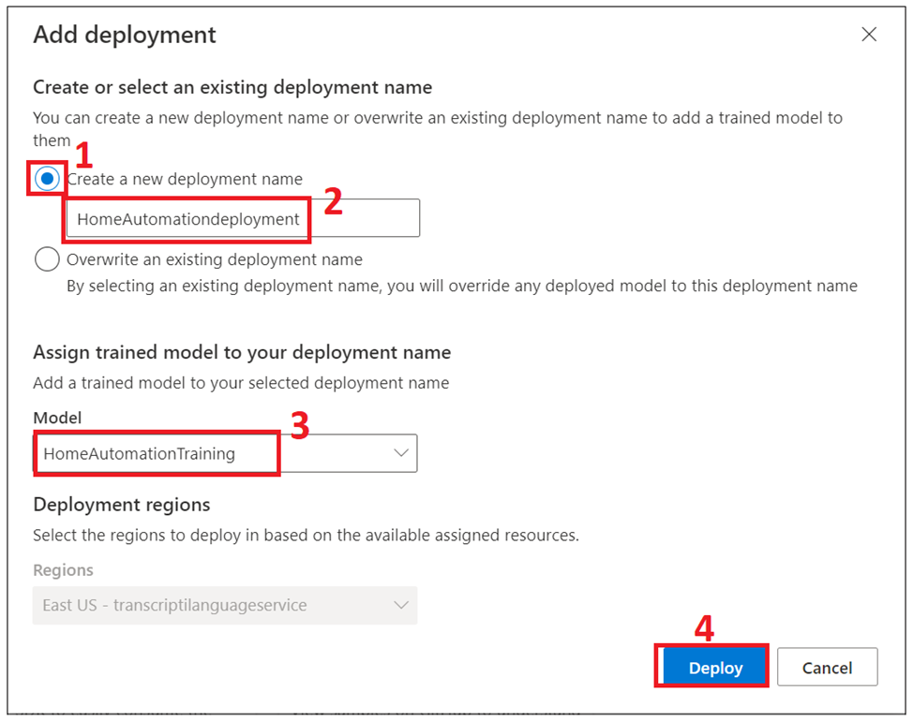
- After deployment is successful, an expiration date will appear next to it. Deployment expiration is when your deployed model will be unavailable to be used for prediction, which typically happens twelve months after a training configuration expires.
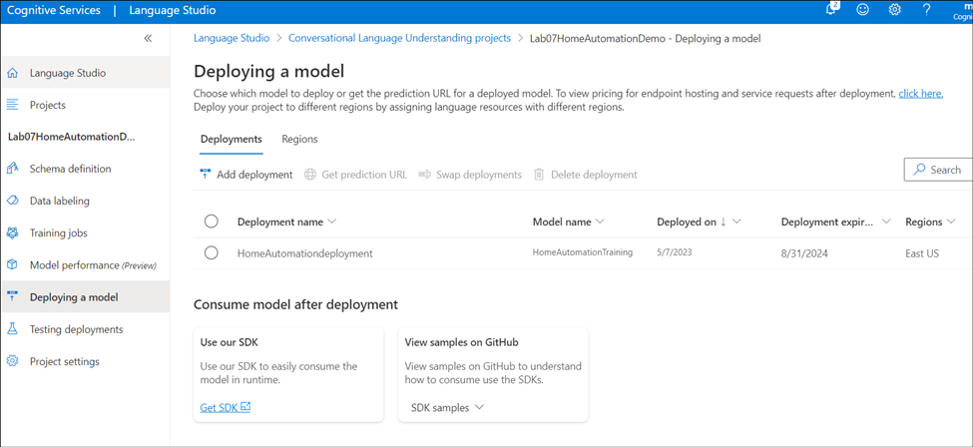
You'll use the project name and deployment name in the next section.

Task 5: Recognize intents from a microphone
Follow these steps to create a new console application and install the Speech SDK.
- Switch back to your command prompt and run cd Recognize-intents
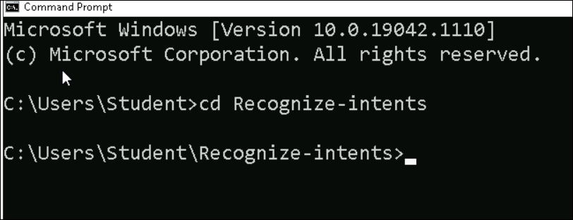
- Create a console application with the .NET CLI. The Program.cs file should be created in the project directory.
dotnet new console
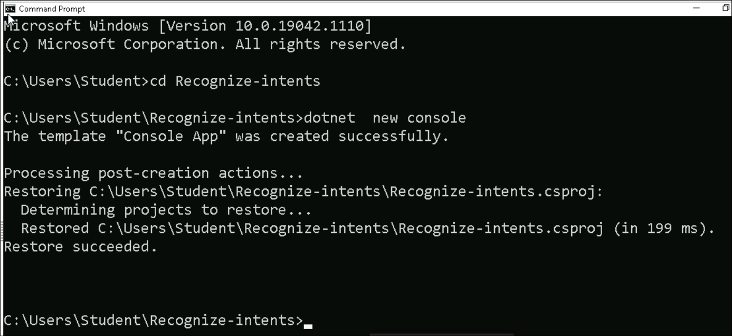
- Install the Speech SDK in your new project with the .NET CLI.
dotnet add package Microsoft.CognitiveServices.Speech
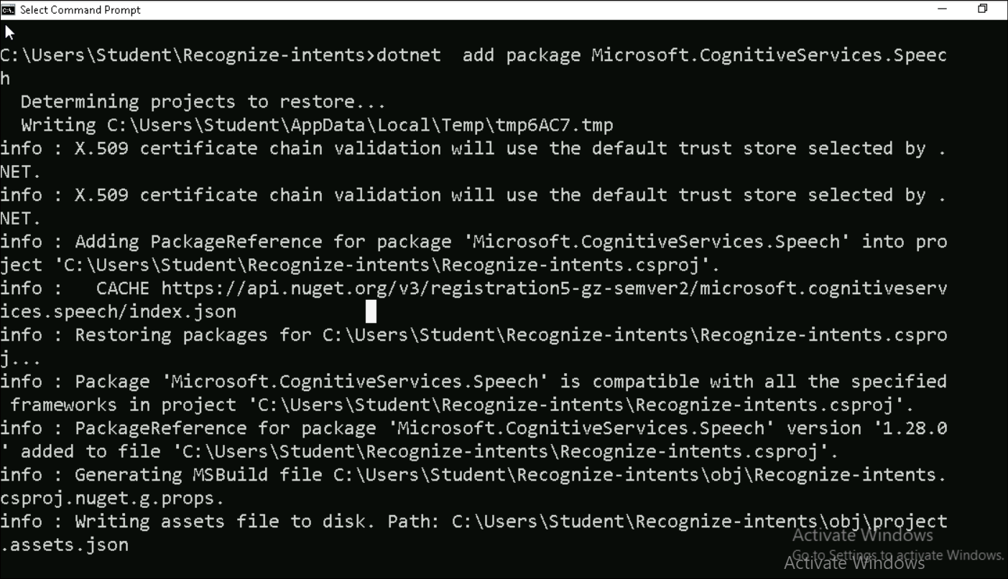
- Open Program.cs using the notepad and replace the contents of Program.cs with the following code.
- using Microsoft.CognitiveServices.Speech;
- using Microsoft.CognitiveServices.Speech.Audio;
- using Microsoft.CognitiveServices.Speech.Intent;

- class Program
- {
- // This example requires environment variables named:
- // "LANGUAGE_KEY", "LANGUAGE_ENDPOINT", "SPEECH_KEY", and "SPEECH_REGION"
- static string languageKey = Environment.GetEnvironmentVariable("LANGUAGE_KEY");
- static string languageEndpoint = Environment.GetEnvironmentVariable("LANGUAGE_ENDPOINT");
- static string speechKey = Environment.GetEnvironmentVariable("SPEECH_KEY");
static string speechRegion = Environment.GetEnvironmentVariable("SPEECH_REGION");
// Your CLU project name and deployment name.
static string cluProjectName = "YourProjectNameGoesHere";
static string cluDeploymentName = "YourDeploymentNameGoesHere";

async static Task Main(string[] args)
{
var speechConfig = SpeechConfig.FromSubscription(speechKey, speechRegion);
speechConfig.SpeechRecognitionLanguage = "en-US";

using var audioConfig = AudioConfig.FromDefaultMicrophoneInput();

// Creates an intent recognizer in the specified language using microphone as audio input.
using (var intentRecognizer = new IntentRecognizer(speechConfig, audioConfig))
{
var cluModel = new ConversationalLanguageUnderstandingModel(
languageKey,
languageEndpoint,
cluProjectName,
cluDeploymentName);
var collection = new LanguageUnderstandingModelCollection();
collection.Add(cluModel);
intentRecognizer.ApplyLanguageModels(collection);

Console.WriteLine("Speak into your microphone.");
var recognitionResult = await intentRecognizer.RecognizeOnceAsync().ConfigureAwait(false);

// Checks result.
if (recognitionResult.Reason == ResultReason.RecognizedIntent)
{
Console.WriteLine($"RECOGNIZED: Text={recognitionResult.Text}");
Console.WriteLine($" Intent Id: {recognitionResult.IntentId}.");
Console.WriteLine($" Language Understanding JSON: {recognitionResult.Properties.GetProperty(PropertyId.LanguageUnderstandingServiceResponse_JsonResult)}.");
}
else if (recognitionResult.Reason == ResultReason.RecognizedSpeech)
{
Console.WriteLine($"RECOGNIZED: Text={recognitionResult.Text}");
Console.WriteLine($" Intent not recognized.");
}
else if (recognitionResult.Reason == ResultReason.NoMatch)
{
Console.WriteLine($"NOMATCH: Speech could not be recognized.");
}
else if (recognitionResult.Reason == ResultReason.Canceled)
{
var cancellation = CancellationDetails.FromResult(recognitionResult);
Console.WriteLine($"CANCELED: Reason={cancellation.Reason}");

if (cancellation.Reason == CancellationReason.Error)
{
Console.WriteLine($"CANCELED: ErrorCode={cancellation.ErrorCode}");
Console.WriteLine($"CANCELED: ErrorDetails={cancellation.ErrorDetails}");
Console.WriteLine($"CANCELED: Did you update the subscription info?");
}
}
}
}
}
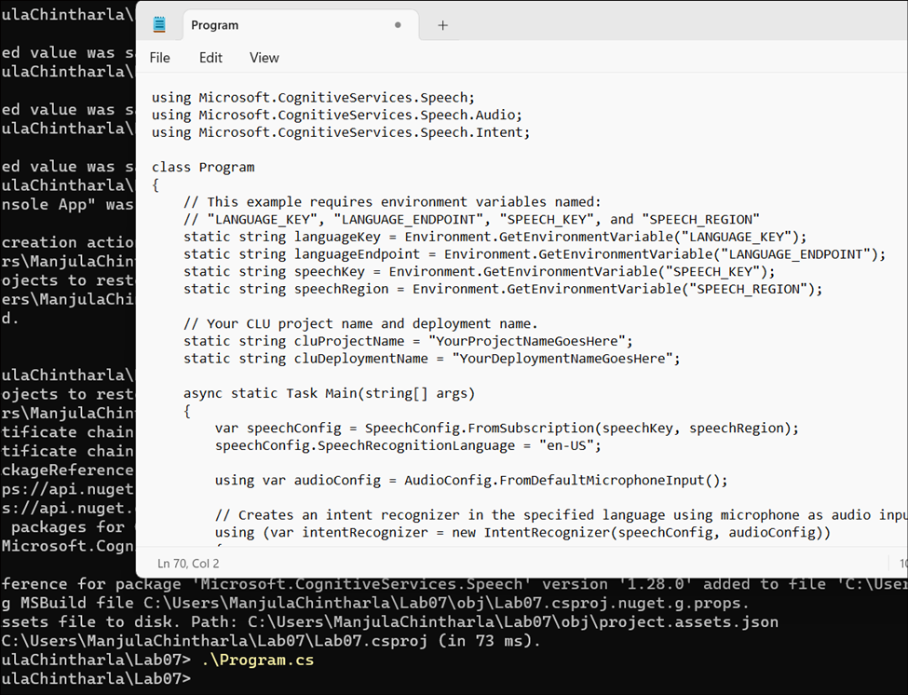
- In Program.cs set the cluProjectName and cluDeploymentName variables to the names of your project and deployment and then save the file.
- We used project name: RI-HomeAutomationDemo and Deployment name: HomeAutomationdeployment
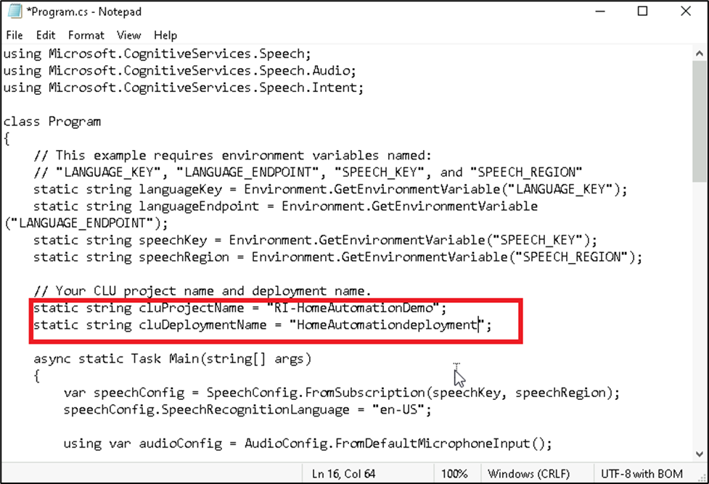
- To change the speech recognition language, replace en-US with another supported language. For example, es-ES for Spanish (Spain). The default language is en-US if you don't specify a language. For details about how to identify one of multiple languages that might be spoken, see language identification.
- Close the console and open it again and navigate to the Recognize-intents folder by executing this command. cd Recognize-intents
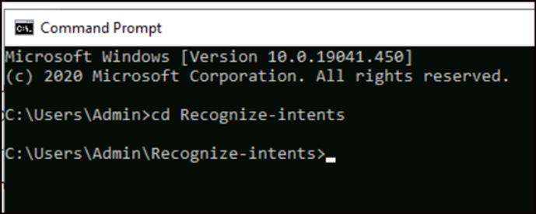
- Run your new console application to start speech recognition from a microphone:
dotnet run
- Speak into your microphone when prompted. What you speak should be output as text:
Speak : Turn on the light
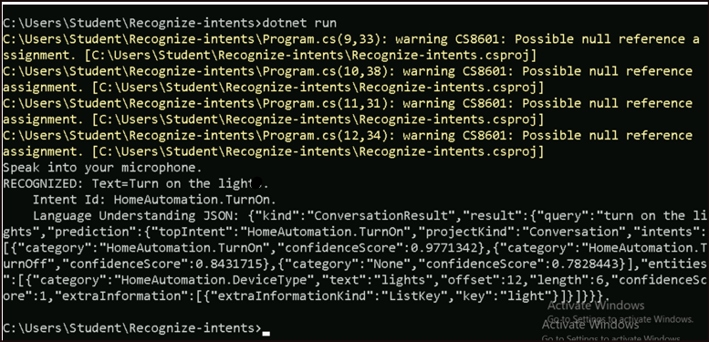

Task 6: Clean up resources
- From the Azure portal, open the Resource group azcogntv-rg1.
- Select the Speech and the Language resources under it and click on Delete.
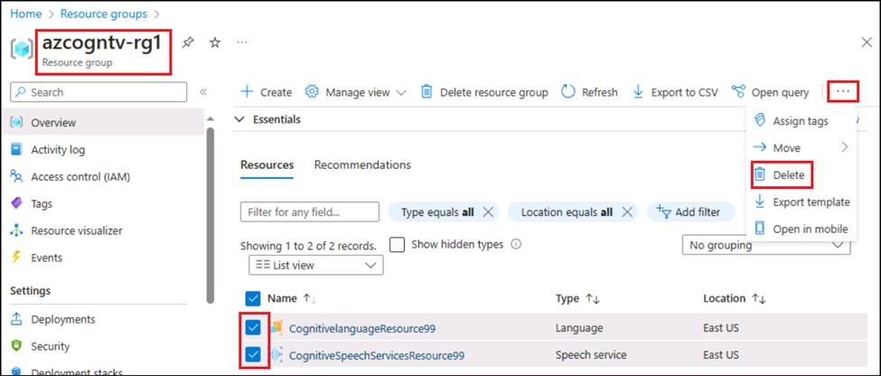
- Type delete in the text box and click on Delete.
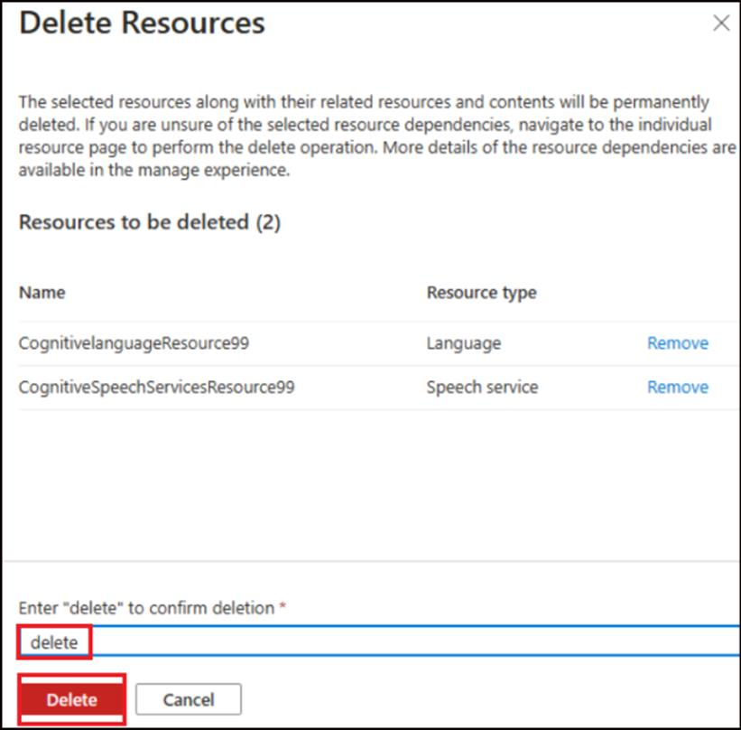
- Click on Delete in the confirmation dialog box.
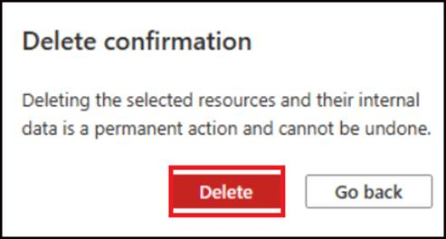
- You should get a success message on deletion.
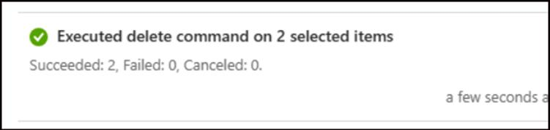
Summary:
In this Lab, you created a Conversational Language Understanding project. You also built a schema and labeled the utterances. You then train, deploy the model in Language Studio. At the end, you recognize the intents from a microphone by updating the code and running the program.cs file.

